**IMDb Movie Industry Analysis Report**

**Uncovering Trends, Insights, and Strategic Recommendations**



**Introduction**

This report presents a comprehensive analysis of an IMDb-style movie database, revealing key trends in the film industry. The dataset includes information on movies, genres, ratings, directors, production companies, and other critical attributes. By leveraging SQL and advanced data querying techniques, we identified actionable insights to guide strategic decisions in movie production.

## **Key Insights & Findings**

### **1. Top Genres & Their Popularity**

Our analysis identified **Drama** as the most popular genre, with **1,078 movies produced in 2019** alone. This indicates a strong audience demand, making Drama a strategic focus for future productions.  
*Recommended Action:* RSVP Movies should prioritize their next project in the **Drama** genre to maximize audience engagement.

### **2. Highest-Grossing Movies**

By ranking the top five highest-grossing movies across the most popular genres, we uncovered trends in box office performance.  
*SQL Function Used:* DENSE_RANK() was applied to rank movies by worldwide gross income within each genre and year, ensuring accurate identification of top performers.

### **3. Production House Performance**

Top-performing production companies in the multilingual category were identified based on median movie ratings above 8.

1. **Dream Warrior Pictures** and **National Theatre Live** excelled in average movie ratings.
2. **Marvel Studios**, **20th Century Fox**, and **Warner Bros.** led in total votes.
3. **Star Cinema** and **20th Century Fox** topped the leaderboard for multilingual films.  
   *Recommended Action:* RSVP Movies should consider partnering with these companies to produce high-quality, globally appealing films.

**4. Actress Performance in Drama**

The top actresses with the highest average ratings (9.4) in the Drama genre are:

1. **Sangeetha Bhat**
2. **Fatmire Sahiti**
3. **Adriana Matoshi**

*Top Choice:* **Tapsee Pannu** with an impressive average rating of **7.74**, showcasing both talent and audience appeal.

### **5. Directorial Success**

**James Mangold** is highly recommended for directing the upcoming project due to his proven track record, high average ratings, and visionary filmmaking.  
*Other Notable Directors:*

1. **Michael Powell**
2. **Emeric Pressburger**

### **6. Lead Actor Recommendations**

For lead roles, we suggest:

1. **Mammootty** (Rank 1 based on median ratings), known for his extensive experience and audience appeal.
2. **Mohanlal** (Rank 2), a versatile actor with strong box-office presence.  
   For side roles:
3. **Vijay Sethupathi** for his regional appeal and ability to connect with diverse audiences.

### **7. Movie Duration Analysis**

The ideal movie duration across genres averages **107 minutes**, balancing audience engagement and storytelling.  
*Recommended Action:* Aim for a similar duration in upcoming productions to align with audience expectations and industry standards.

### **Visual Analysis Report**

This report provides a comprehensive analysis of the movie industry, modeled after IMDb data, to offer actionable insights for RSVP Movies' next project.

### **1. Genre-wise Movie Distribution:**

### The graph shows the distribution of movies across various genres. Drama emerged as the most popular genre, followed by genres like Fantasy, Thriller, and Comedy. With a total of 4285 drama movies, it stands out as the highest among all genres. Other genres like Action, Horror, Romance, and Adventure also have a significant presence, but they are less frequent in comparison. This distribution highlights the diversity in movie production, with some genres like Drama dominating the film industry."

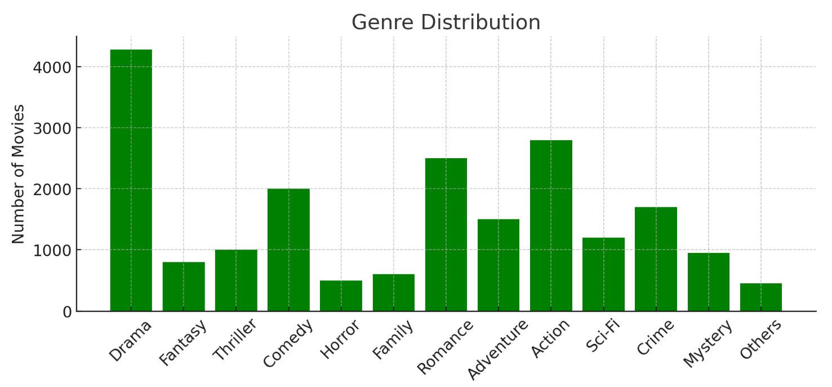

**2. Top Production Houses by Votes :**

The production houses with the highest number of votes received for their movies are recognized for their significant impact on the industry. This analysis identifies the key players in the film production sector based on the popularity and engagement of their movies, as reflected in the vote count.

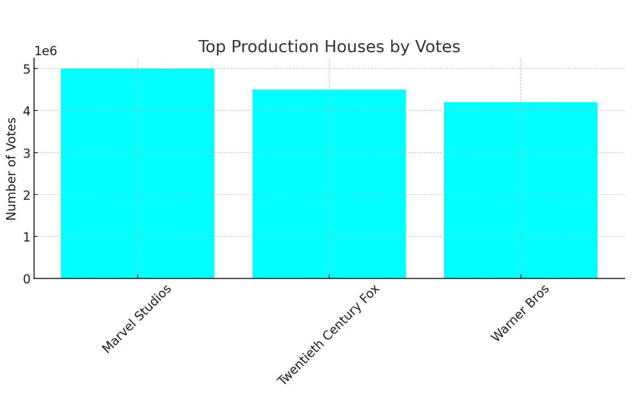

**3. Average duration by Genre :**

The graph illustrates the average duration of movies across different genres, revealing how long films tend to be within each category.

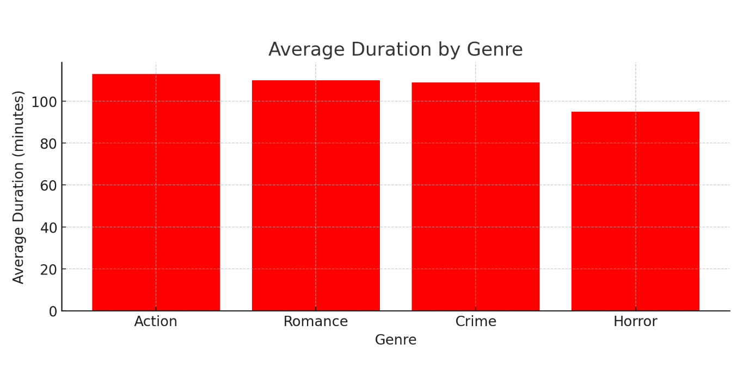

## 

## **Methodology**

1. **Data Extraction:** SQL queries were used to join multiple tables, including movie, ratings, genre, and director_mapping.
2. **Aggregation & Ranking:** SQL functions like COUNT(), SUM(), AVG(), and DENSE_RANK() provided clarity in identifying top performers.
3. **Window Functions:** Moving averages and running totals were calculated to observe trends over time.

### **Conclusion**

This analysis highlights the power of data-driven decision-making in the film industry. By examining key metrics such as genre popularity, box office performance, production house success, and talent ratings, we have provided RSVP Movies with actionable insights to guide their next project.

As the entertainment landscape evolves, leveraging advanced analytics and insights from data is essential for staying competitive and meeting audience expectations. With a strategic, data-first approach, RSVP Movies is poised to create a film that resonates with audiences and dominates the box office.